Use-Case Realization Report (Design)
Delete Section

Issue <1.0>
Revision History
Date | Issue | Description | Author
<25/Sep/09> | <1.0> | <Initial version> | <Thomas Yap>

Table of Contents
1. Brief Description 4
2. Flow of Events 4
2.1 Standard Flow 4
2.1.1 Delete Exam 4
3. Interaction Diagrams 5
3.1 Collaboration Diagram for Delete Section 5
3.2 Sequence Diagram for Delete Section 6
4. Participating Objects 6
5. Class Diagrams 7
5.1 Class Diagram for Delete Section 7
6. Derived Requirements 7

Use-Case Realization Report
Delete Section

Brief Description
This use case enables the controller to delete section with its properties and parameters. It involves displaying the menu and select from list to remove the record.

Flow of Events
The standard flow of events for this use case and any exceptions are described in the following subsections. The events are described in terms of Actors and Design Objects.

Standard Flow
This use case covers the Section Maintenance - Delete Section. The standard flow of these events is described below.

Delete Section
The running of the application is shown in section 3.1. The flow of event is as follow:

- When the application start, the first operation to be performed is the startup operation of the main controller. This operation will create all the control objects and the entity objects necessary for operation Delete Section:
  - The control object created is: MCQBL Controller
  - The entity objects created are: mcq_exam_master, mcq_section_master.

- The main controller will start the main function menu:
  - To start Delete Section, operation page_load() is activated by MCQBL Controller to display an Section form.
  - PopulateObjectList() is activated and the Section interface will display the section list.
  - Portal Admin then select the section id to be deleted. Upon confirmation by clicking delete button, the record will then be deleted from table mcq_exam_master and mcq_section_master using operation DeleteSection. It them update mcq_exam_master by invoking UpdateExam().
  - The delete request can be cancelled by clicking cancel button and no data will be altered.

- Step 2 will be repeated until all deletions are completion. Then controller will terminate the application by issuing operation close.

Interaction Diagrams

Collaboration Diagram for Delete Section
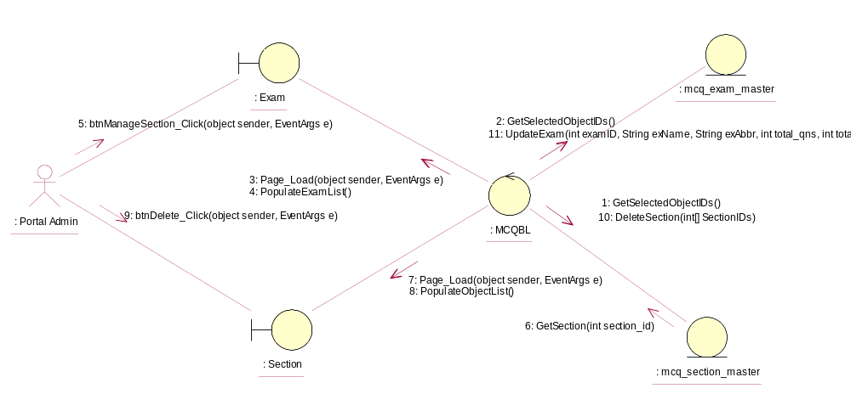

Sequence Diagram for Delete Section
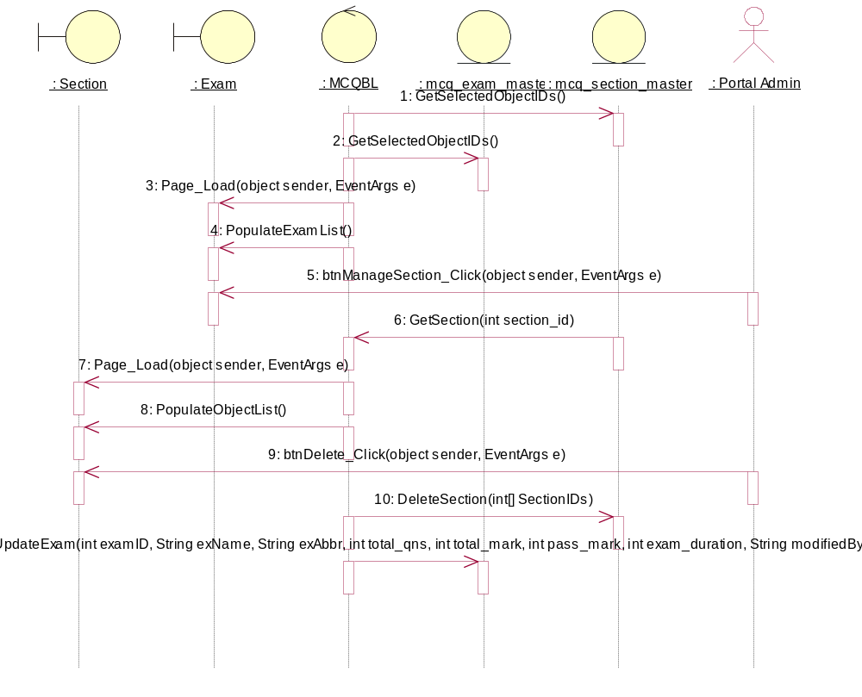

Participating Objects
: Exam

: mcq_exam_master

: mcq_section_master

: MCQBL

: Portal Admin

: Section

Class Diagrams

Class Diagram for Delete Section
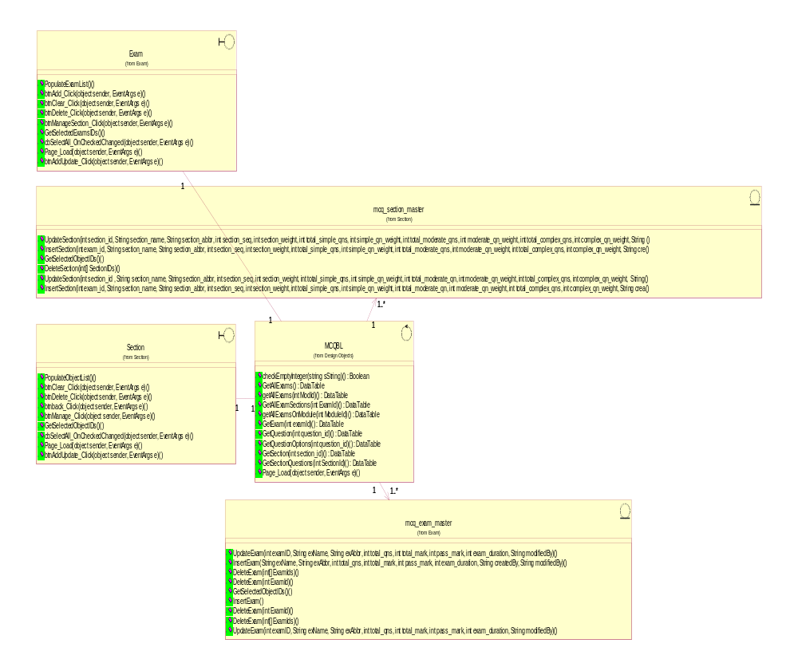

Derived Requirements
[enter the derived requirements here]

